**ALINYIIKIRA JUNIOR SCHOOL, NAKWERO**

**BEGINNING OF TERM 3 ASSESSMENT 2024**

**MIDDLE CLASS**

**LEARNING AREA 3 (HEALTH HABITS)**

Name: __________________________________________________________________

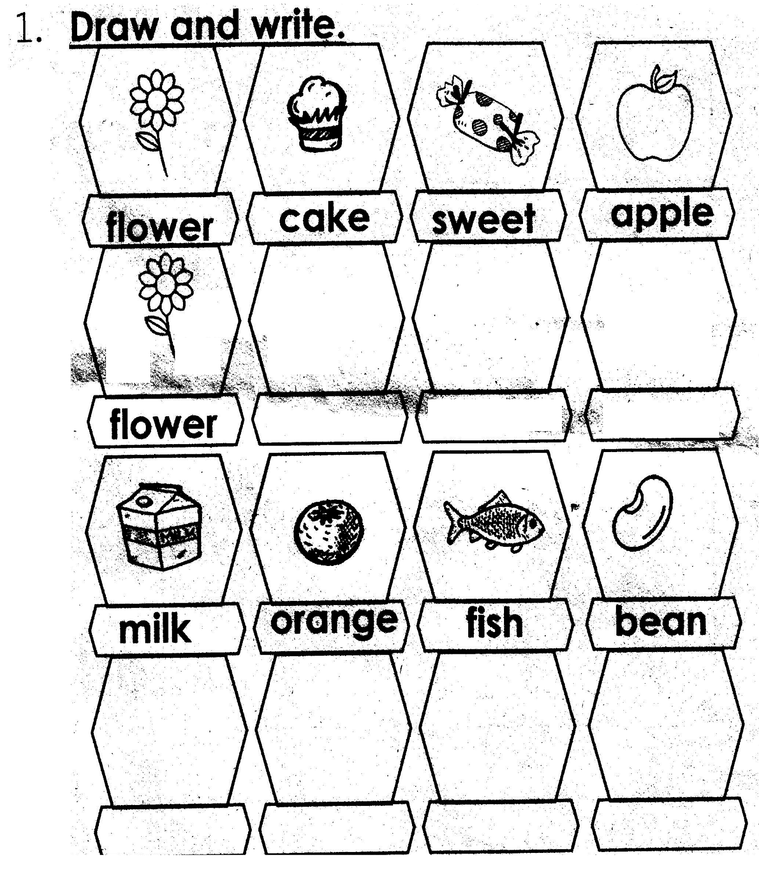

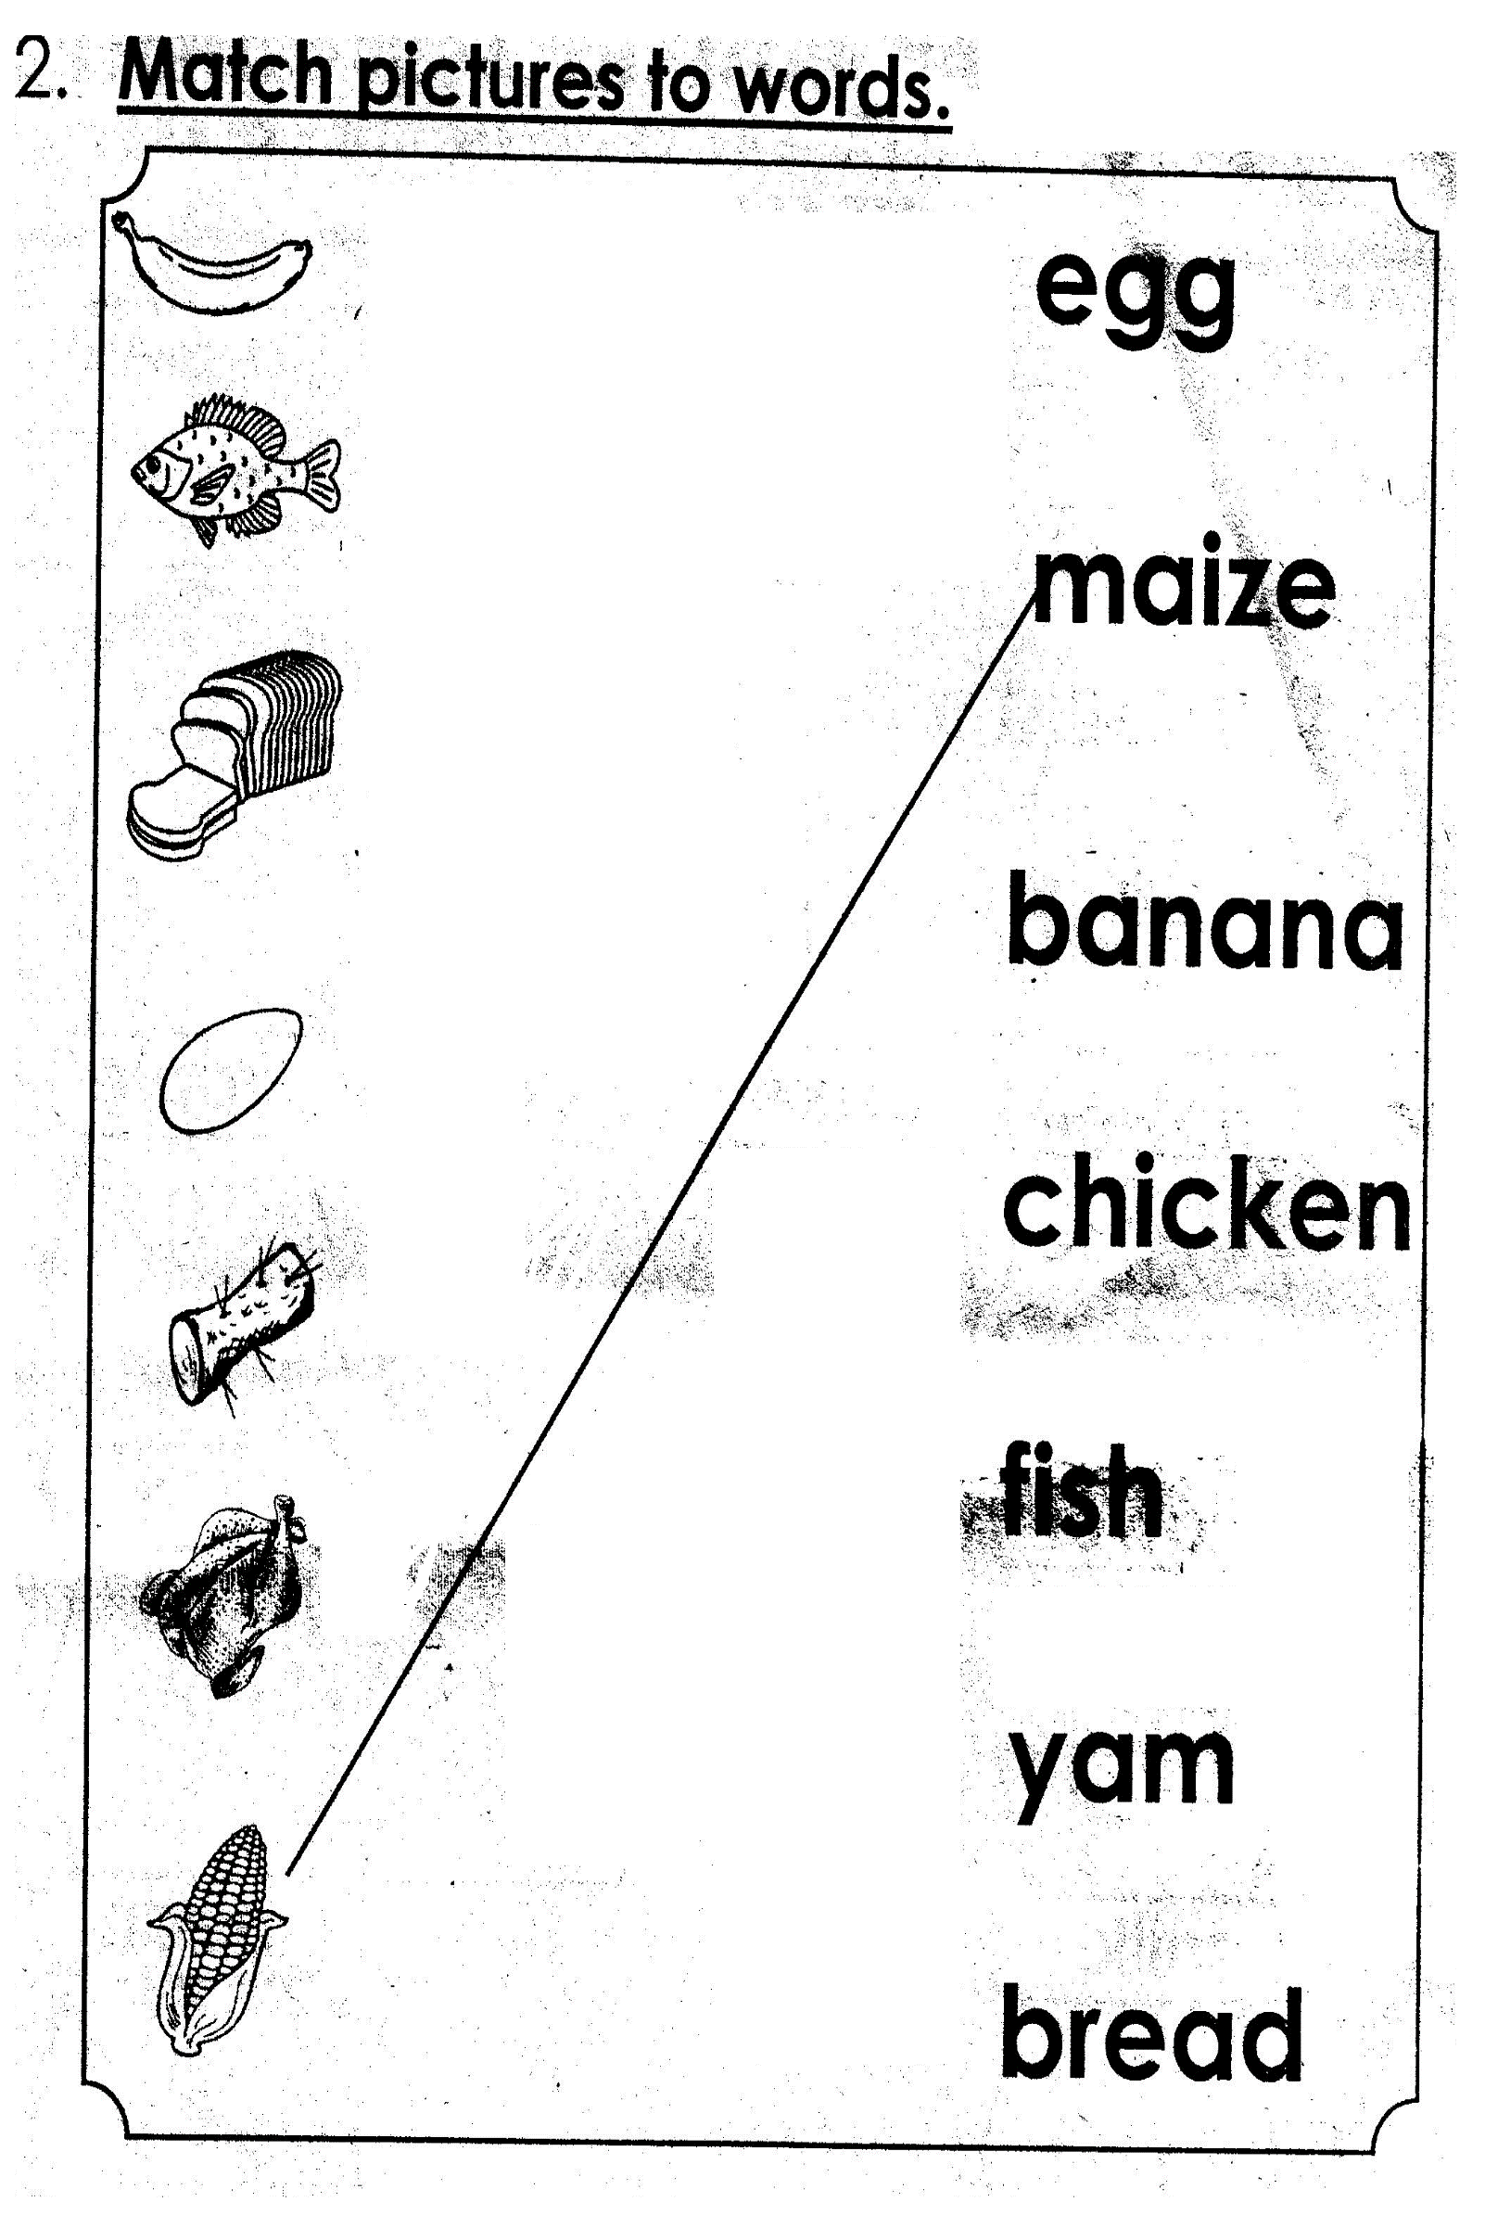

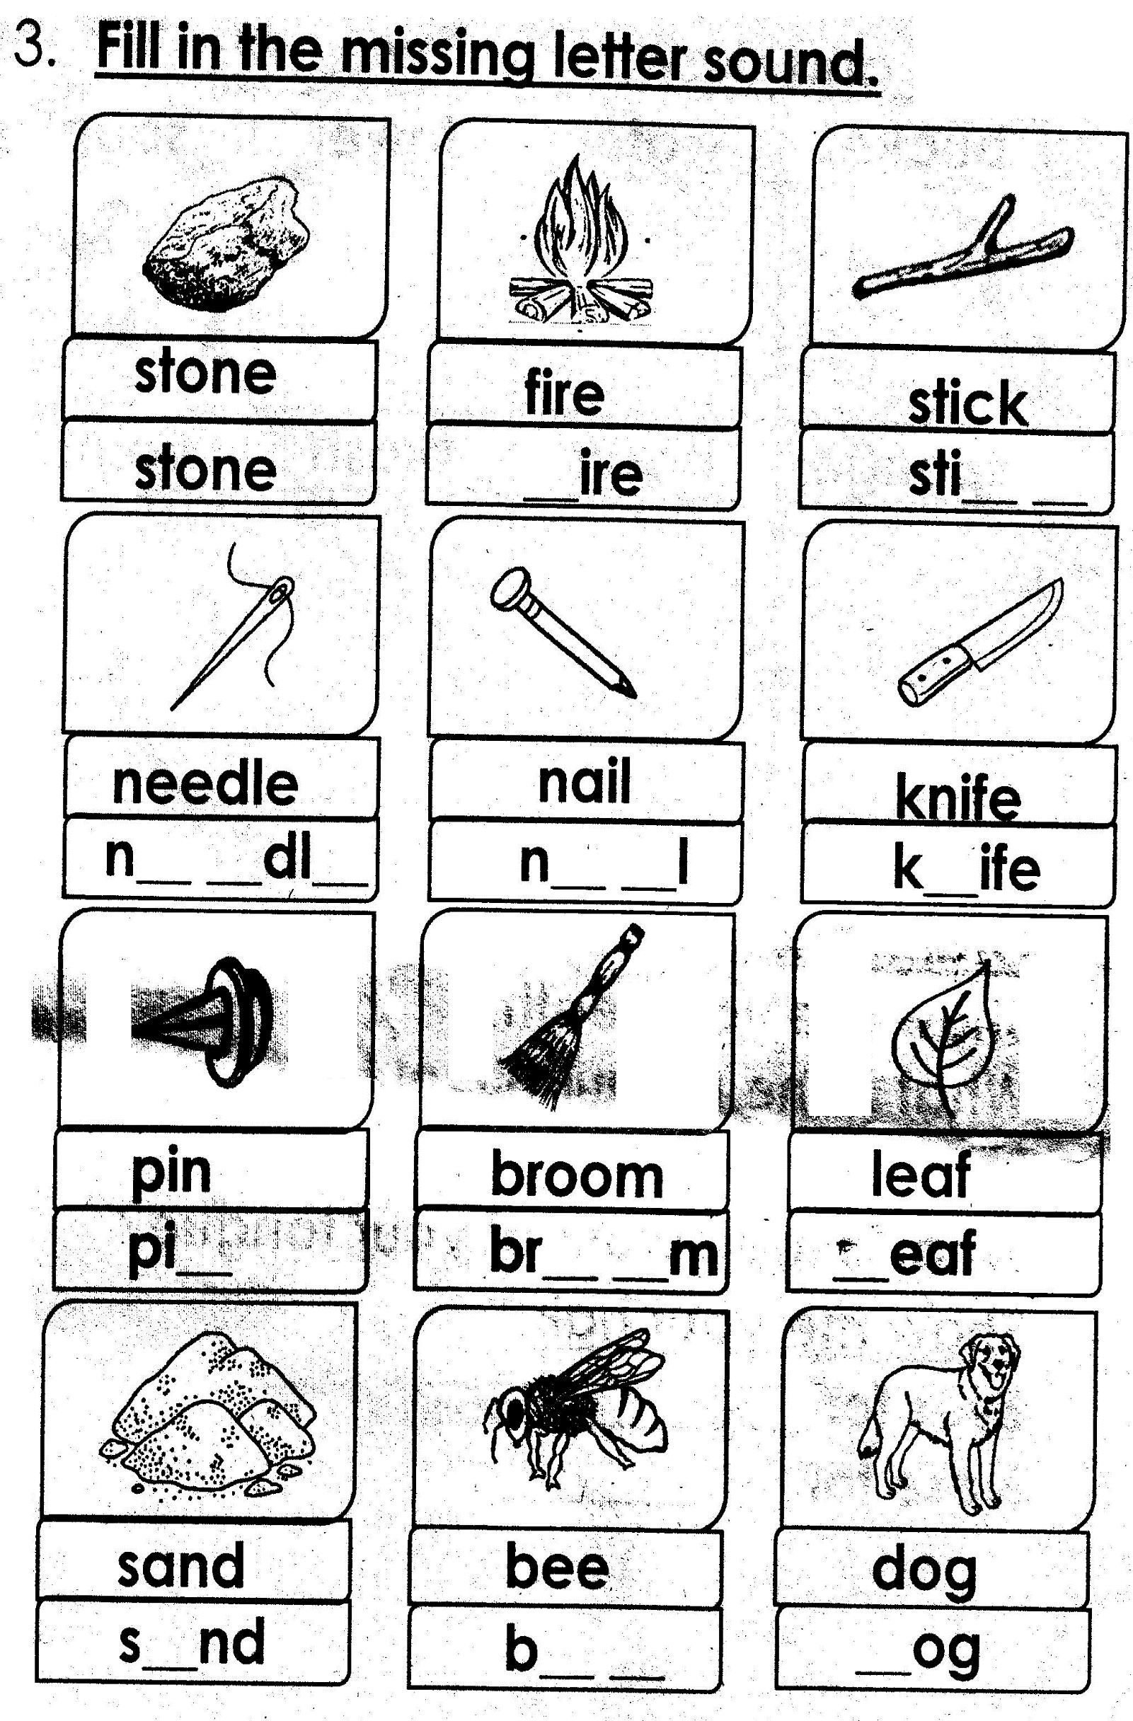

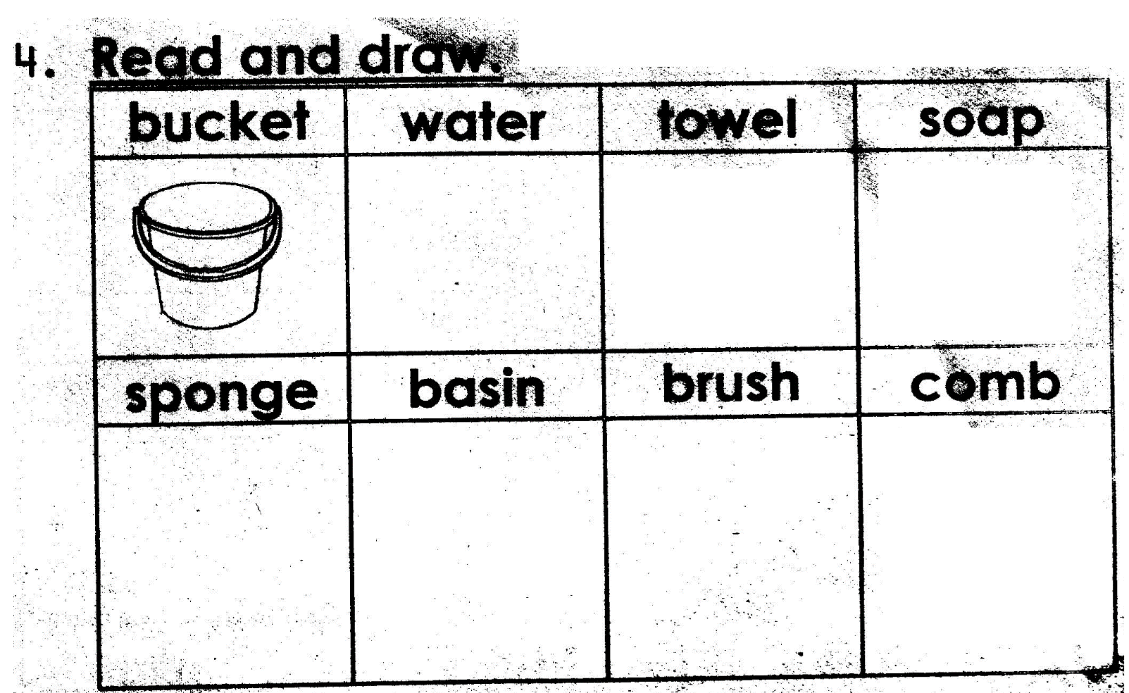

**5. Oral Work:**

Show me your teeth.

What is the colour of your teeth?

Show me your tongue.

What is the colour of your tongue?

Show me your hair

Eyes for ____________________________

Nose for ____________________________